**JIVE PUBS MILLING & FOODS**

**NIGERIA LIMITED.**

**.**2020

**OVERVIEW.**

We are an offshoot of PHINOMAR NIG LTD. We **mill** tons of organic soya seeds through two major processes to obtain products like soy meal, soya full-fats, soya crude oil, and soya sludge. These products are beneficiary/important to the likes of poultry farmers, piggery farmers, fishery farmers, vegetable oil refining industries ,feed manufacturing companies….etc. The use of the by-products of this organic seed has been expanded beyond the above mentioned and we want to explore eventually those diversity.

**THE PRESENTER;**  **Mr. Byron Ayalogu**.

-BACHELORS’ DEGREE; MECHANICAL ENGR. MADONNA UNIVERSITY.

**-Work Experience;** PHINOMAR NIG. LTD (1YR as Interim Production/statistics Manager MILLING & FOODS

-FOUNDER EAVOR FOODS INC.

-Co owner/Director JIVE PUBS MILLING & FOODS NIG. LTD.

**Simplified Analysis.**

**MATERIAL, PRODUCTS**

**whole soya bean seed** ------via MILL------ **soya meal/less fat, soya crude oil** and **soya sludge.**

*Prices =N146,000/ton*   *N152,000/ton N600,000/ton N2,000/25kg*

OR

**whole soya bean seed**-------via MILL------**soya meal/full-fat**.

*Prices =N146,000/ton N165,000/ton*

**NB; DATA**

One truck = 30 tons seed, 30tons = 21tons of soya meal/less fat (50kg/bag)

= 4.5tons of soya meal/full-fat (50kg/bag)

= 3.5tons of soya crude oil (12-13%)

= 150kg of soya sludge (25kg/bucket)

With these products outcome, Return On Investment**(ROI**) = >10% - (see full detail in cash flow)

Return On Equity**(ROE**) => 13% next page.

**TURNOVER ADVANTAGE; Higher Tonnage Consumers.**

-we are in contact with almost 80% of PHINOMAR NIG. LTD customers through MR Byron Ayalogu

**Below are customers that buy in higher tonnes;**

**Tonnage capacity**

-We have received calls from - ENVOY OIL NIG LTD. Onitsha >30 tons of oil

-NEXT INVESTMENT .Aba owerri road >15 tons of meal

-JOE CAN NIG LTD Umuahia >30 tons of meal

-We have also made contacts with - INTERCIL NIG LTD Emene Enugu >7 tons of oil

-WILSONS FACTORY. Nsukka >15 tons of oil

-DEZERN NIG. LTD. Enugu Ogui road >10 tons of oil

…and other local retails and distributors.

*We will also have **Mini** distribution and informative centers in new market and garriki to increase customer services with a strategic delivery system.

*We want to bring in a new atmosphere into the market and effectiveness towards the end use of our products, that's our advantage.

## **SALES; BRIEFED**.

**THE PRESENT GENERAL MARKET;**

In this market currently, we have three groups of players;

+ **Player no.1;** The bird feed producers,

**+ Player no.2;** The local market feed mixers,

**+ Player no.3; Bird major feed component** producers/wholesalers and retailers.

**Note; E**very market player needs the **major component** to have a complete bird feed and this major component can be categorized into; ***less fat, full fat and solvent extract. (recognized in Nigeria).***

These **players** are remotely handling their activities and basically OK with the already formed market’s fair share, and working mostly towards increasing their own pie off that already available total market share by looking for the cheapest way to make more profit which compromises their efforts, mostly like every other conventional person who can afford to sale these goods would do.

In this situation **Player no 1.** is a special case.

**JIVEPUBS’ APPROACH AND FORMULA**;

We are going to come into this market not just to grab a bite off that already formed fair share but also create/introduce a new approach which would lead to a shift and maintaining that new shift as the originators by having a signature. With a **direct customer approach** we are going to have our own functional **feed formula & routine** that really works and also bring in more product variety not just for the **bird** rearing farmer, but also for **piggeries and fisheries.** We are going to have a **scheme of profit** for every engaged rearing client in those categories above

To set a balance and increase our **market share** quickly, we are going to **leverage these services** with any market body that falls in the category of **player no.2** for us to be able to spread faster to those animal rearers. We are also going to connect with **macro rearing farmers** around Enugu state.

We are going to introduce our ***customer service center and warehouse*** in the markets to increase our **proximity** with the targeted audience and also monitor our leveraged services and that would enable us to pick important informations that would gradually allows us to take certain quick decisions and adjustment in certain times without relying on our competitors.

With all these, we will still have to introduce a **strategic delivery system** to nearbys and mostly our top preferences.

**Advertisement** through **referrals** would work and also be the cheapest because of-course our **quality** would speak for itself, but we would need some kind of **public sensitization** to put our audience on track.

**NOTE;** DEALS WITH **HIGH TONNAGE COMPANIES** AS STATED IN THE FIRST PAGE WOULD ALSO FORM PART OF OUR SALES METHOD.

Graphic illustration of **sales growth** after an **initial** constructive/deceive two months

Fg;1, sales on soy less fat averaging 120tons/month the 1st 7 months & inclines to 200tons/month.

# Graphic Sales Projection.

Fg;2, sales on soy crude oil averaging 14000kg/month the 1st 4 months and inclines to 21000kg from 7th month.

Fg;3, sales on soy sludge averaging 700kg/month the 1st 6 months and inclines to 900kg/month from 8th month.

## JIVE PUBS’ CREDIT LIFE.

**INTERESTS.**

**CREDITORS (A);** *Individuals and Co-operations*.

We are offering a short term **credit life** for an interested individual or Co-operation, that would earn you a reasonable **interest of 12%** + incentive(for trusting our capability)

The table below represents period of returns on invested interest capitals, with incentives

## *Table Of Interests From Funding Proceeds.*

**Fund Amount ~~N~~ Fund Processing Time ROI (12%) & Spreadable Incentive**

**& initial drop**

~~-N~~3,000,000M 5 months 5th month & 6 months -

~~-N~~5,000,000M 5 months 5th month & 8 months -

~~-N~~10,000,000M 7 months 7th month & 11 months ~~N~~250,000

~~-N~~20,000,000M 10 months 9th - 10th month & 20 months ~~N~~500,000

~~-N~~50,000,000M 15 months 11th - 15th month & 48 months ~~N~~1,000,000M

**ROI** = RETURN ON INVESTMENT

**CREDITORS (B);***Product related Companies.*

This section is for Companies or business individuals interested in depositing cash for any of our products. Depending on the cash value, an incentive will also be attached. The stock value for any deposit will require a period of time.

Table below;

**Value Equivalent Stock Table.**

**Negotiable;**

**Products Unit Price/KG Value Deposit Stock Equivalence(KG) Incentive(KG) Time(wks)**

Crude Oil ? ~~N~~5,000,000 ? 200kg 10wks

“ “ ~~N~~10,000,000 “ 500kg 10wks

“ “ ~~N~~20,000,000 “ 1000kg 15wks

NB; Soya less fat and soya sludge can be represented and negotiated in similar format, but with a varying unit price.

**GUARANTOR; STANBIC IBTC BANK PLC.**

JIVEPUBS NIG LTD is in business and can make an arrangement with Stanbic ibtc bank plc to guarantee this risk.

**EXIT PLAN;**

In view of a lingering catastrophic decline, a meeting should be heard to understand why, and only if no solution is **dim fit after trials**, an investor can call for an exit with no pro rata interest.

## EQUITY.

**FOR EQUITY INVESTORS;**  We have covered Assets both in Production,Technical Operations and **Outstandings** to make the business work. The facilities in our custody can turnover >360tons of soya seed a month. The storage facilities are also intact. We lack in business running and market strategy capital.

***With these****;*

We have 390,000 available shares for sale at N55 per share. Return of investment from projected proceeds is >13% by 2nd year. But >6% at 1st year

**Payment of dividend** will be negotiated. Every other aspect depending on the interest of an investor is negotiable.

**INFLUENCE FROM FUNDING;**

Work and operating capital

Easier access to raw materials

**Proximity** towards our target audience and opportunity to flex new identified options (crucial factor)

Create a challenging market follow through & awareness

Access to power/energy alternative.

**GUARANTOR; STANBIC IBTC BANK PLC.**

JIVEPUBS NIG LTD is in business and can make an arrangement with Stanbic ibtc bank plc to guarantee this risk.

**EXIT PLAN;**

In view of a lingering catastrophic decline, a meeting should be heard to understand why, and only if no solution is **dim fit after trials**, an investor can call for an exit with no pro rata interest.

**N/B; T**he pandemic is already a global problem which has increased the time cost in business. We are putting that into account too; the JIVE PUBS **cash flow projection** is rather a very cautious estimated format.

**ASSETS AND FACILITIES.**

**Milling Extruders, Pressers and Cruchers.**

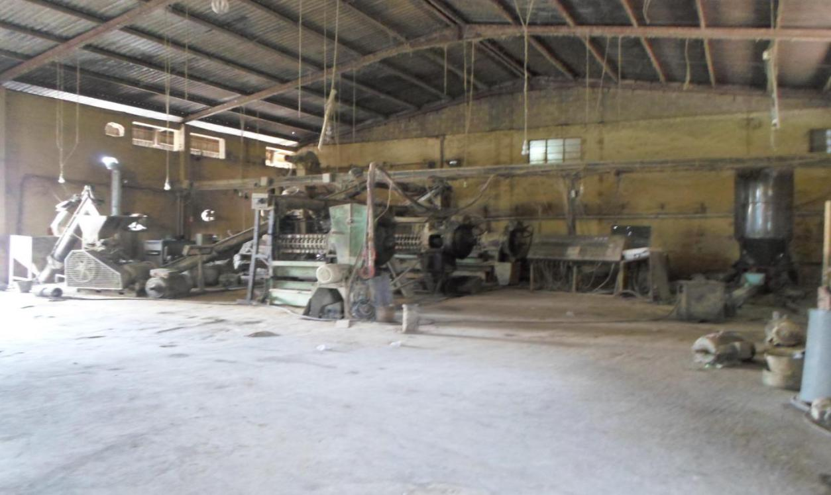

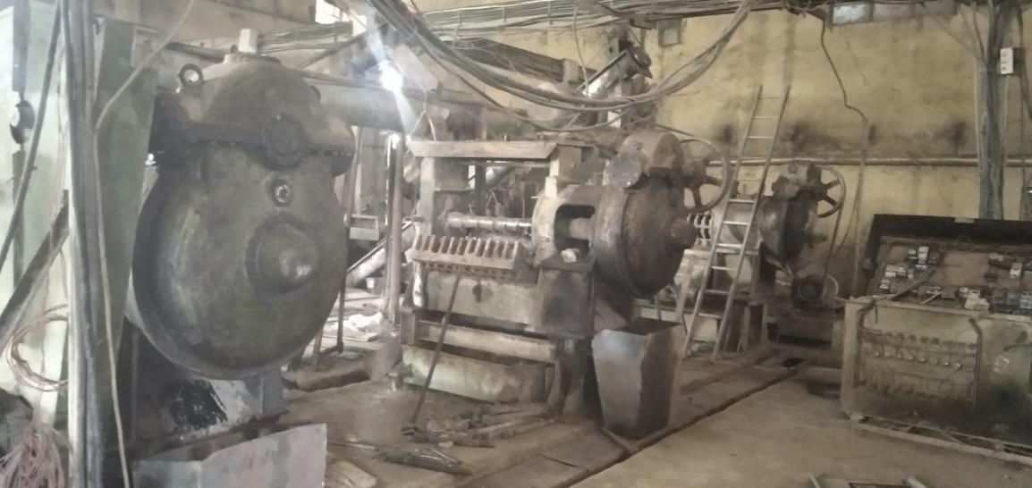

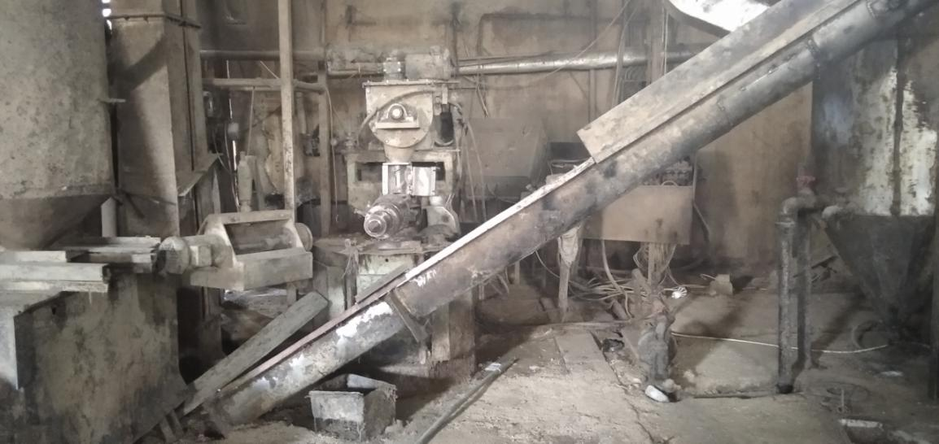

**OIL STORAGE FACILITES.**

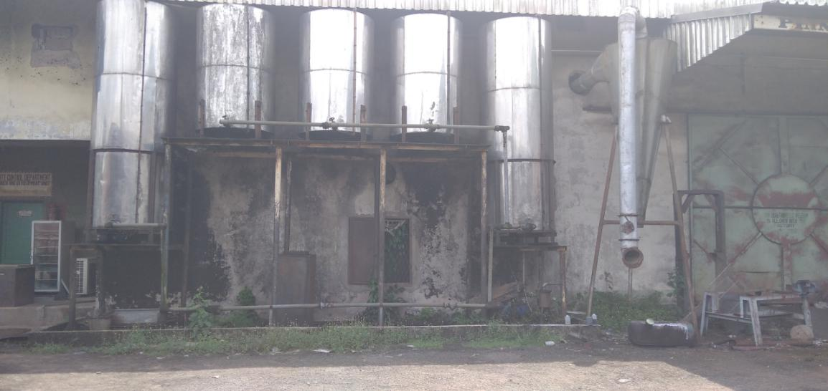

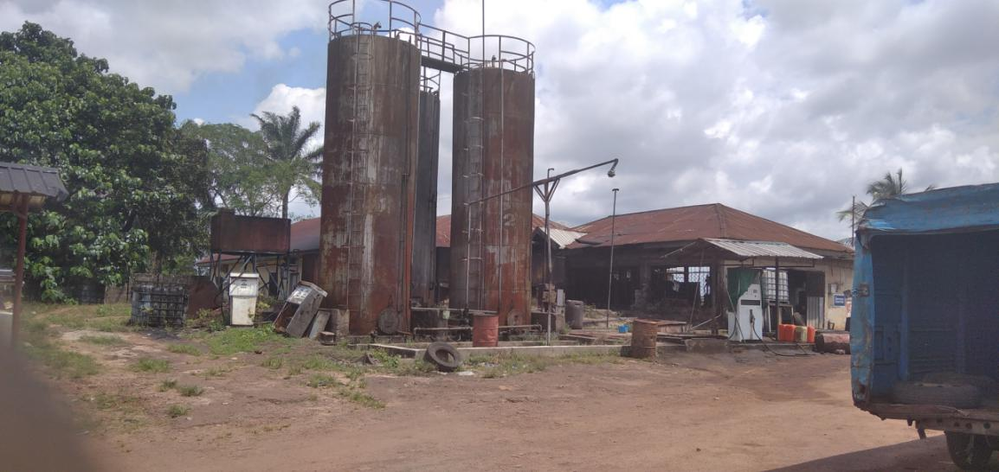

**DISTONER.**

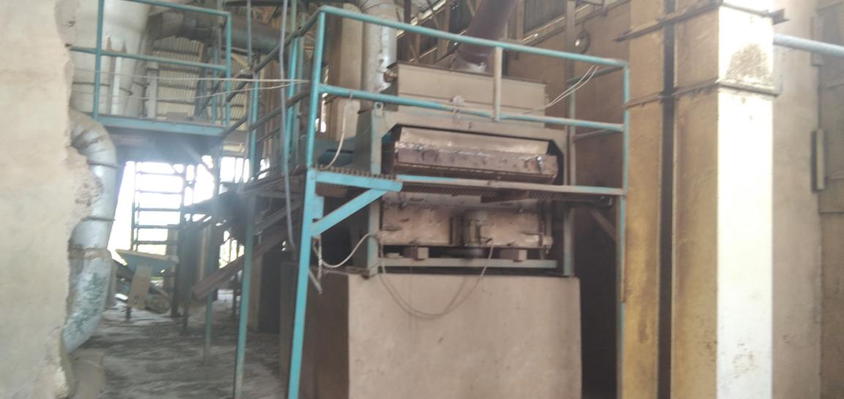

**WAREHOUSES AND STORAGE.**

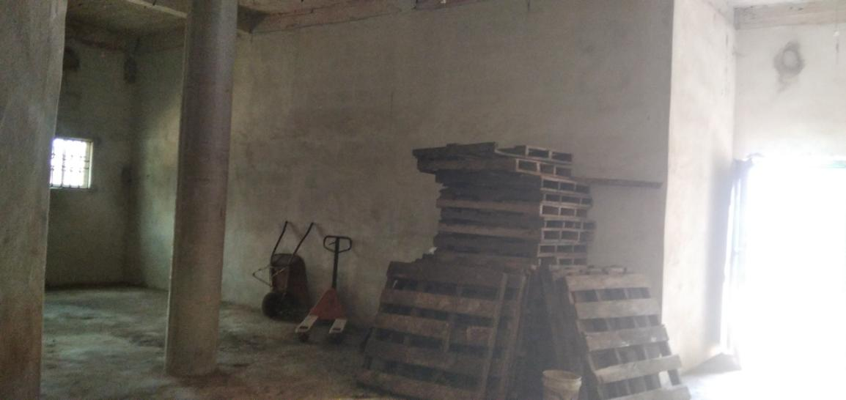

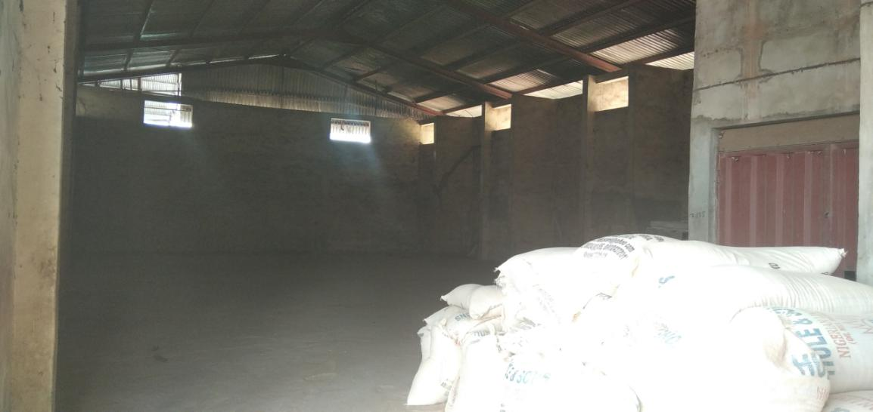

**PACKAGING BAGS.**

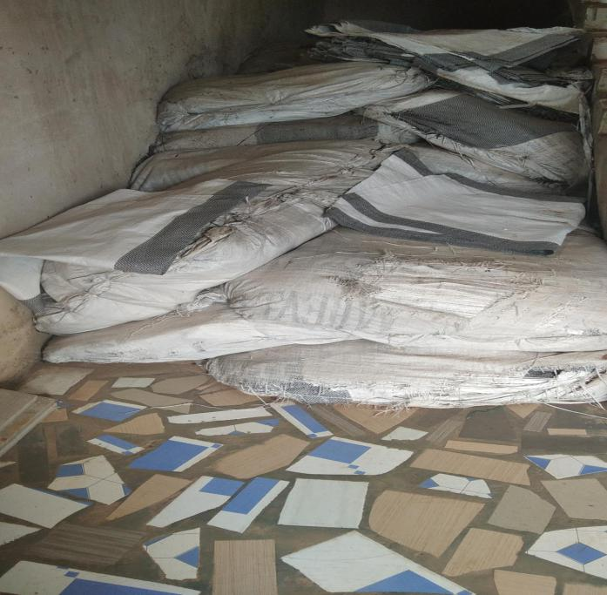

i.

**Content.**

+ Market brief and projections.

*- Model canvas.*

- Info-graph(revenue model)

*- Overview.*

*- Sales & projections.*

*- Cash flow(1st year to 4th year).*

+ Interests and equity.

*- Credit life*

*- Equity & revenue pie.*

*- Facilities(production & storage).*

*- Organo-tech & ergonomics.*